# Brainstorm

**TIP**

You can select a sticky note and hit the pencil [switch to sketch] icon to start drawing!

## Before you collaborate

### A little bit of preparation goes a long way with this session. Here’s what you need to do to get going.

**10 minutes**

## 1

**Define your problem statement**

### What problem are you trying to solve? Frame your problem as a How Might We statement. This will be the focus of your brainstorm.

**5 minutes**

## 2

**Brainstorm**

### Write down any ideas that come to mind that address your problem statement.

**10 minutes**

## 3

**Group ideas**

### Take turns sharing your ideas while clustering similar or related notes as you go. In the last 10 minutes, give each cluster a sentence-like label. If a cluster is bigger than six sticky notes, try and see if you and break it up into smaller sub-groups.

**20 minutes**

## 4

**Prioritize**

### Your team should all be on the same page about what's important moving forward. Place your ideas on this grid to determine which ideas are important and which are feasible.

**20 minutes**

# & idea prioritization

**TIP**

Add customizable tags to sticky notes to make it easier to find, browse, organize, and categorize important ideas as themes within your mural.

Use this template in your own brainstorming sessions so your team can unleash their imagination and start shaping concepts even if you're not sitting in the same room.

**10 minutes** to prepare

**1 hour** to collaborate

**2-8 people** recommended

1. **Team gathering**

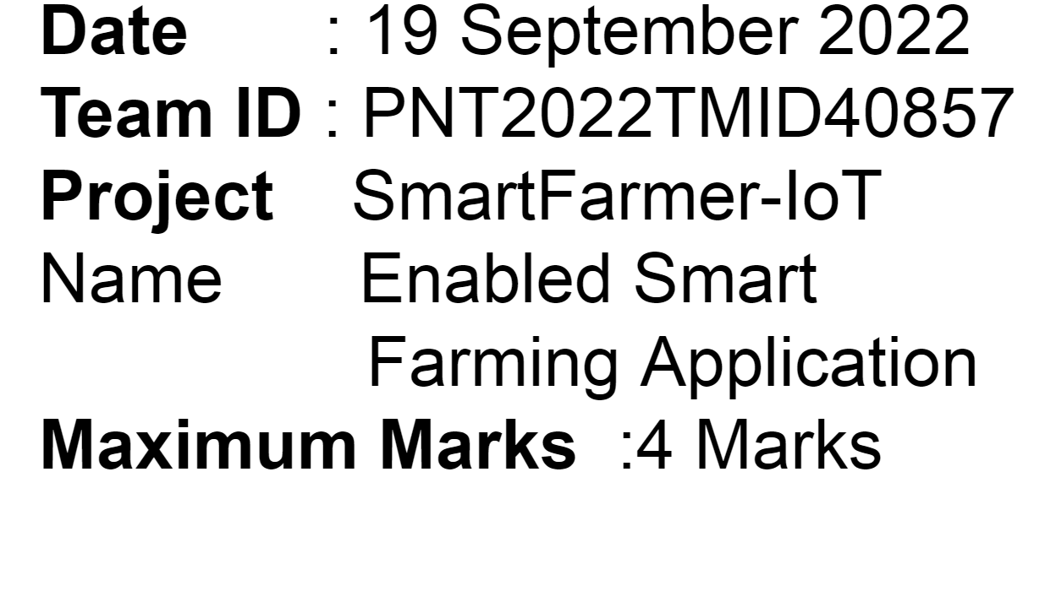Define who should participate in the session and send an invite. Share relevant information or pre-work ahead.

1. **Set the goal**

Think about the problem you'll be focusing on solving in the brainstorming session.

1. **Learn how to use the facilitation tools**

Use the Facilitation Superpowers to run a happy and productive session.

[**Open article**](https://support.mural.co/en/articles/2113740-facilitation-superpowers)

**PROBLEM**

Most of the rural area people can't implement the IOT devices because of they don't know about the device uses and It is difficult to use

it

**Key rules of brainstorming**

To run an smooth and productive session

**Venkatesh.P**

Within a minute it can alert in the display

It is a automation device it can reduce the work

by educating them about the iot devices

This application or software will suggest every time to acces sthe whole system

It can store all the datas in cloud.so, user can collect the details of the activities of the crop.

new and improed technolgy hep farmers effectively

to encourage digital and financia inclusivity

It can notify the problems that occur in the field

**Saranya.P**

**Yogananthan.G**

saving in labour and field preparation cost

balancing the need of devices to ensure the device effectively

software inter face will be under standable

ensure digital and it awareness

it includes to increse enonomic impact

For using various smart agricultural gadgets farmers have gained better control over the process

high accuracy of field encryption

it controls various parameters on their farms

iot can fullfill the customers needs

This application or software will suggest every time to acces sthe whole system

It will automatically moniter all the activities of field.

it can show the fertility of the land.so, farmer can use the required fertilizer.

connect skilling interventions to market

It can be easy to use by controlling the device form home

For using various smart agricultural gadgets farmers have gained better control over the process

It can notify the problems that occur in the field

suitable for all types of soil

serve variety of electronic services to villages

ensure digital and it awareness

Stay in topic. Defer judgment.

connect skilling interventions to market

a secured cloud based server created to store data secrely

easy to use for the users

It can be easy to use by controlling the device form home

It will automatically moniter all the activities of field.

suitable for all types of soil

Encourage wild ideas. Listen to others.

to encourage digital and financia inclusivity

Within a minute it can alert in the display

**Importance**

it can show the fertility of the land.so, farmer can use the required fertilizer.

high accuracy of field encryption

suitable for all types of soil

##### If each of these tasks could get

it includes to increse enonomic impact

by educating them about the iot devices

connect skilling interventions to market

it includes to increse enonomic impact

help farmers for intensive agriculture

high accuracy of field encryption

to encourage digital and financia inclusivity

saving in labour and field preparation cost

Go for volume. If possible, be visual.

done without any difficulty or cost, which would have the most positive impact?

**Kalaivani.B**

serve variety of electronic services to villages

#### TIP

saving in labour and field preparation cost

##### Participants can use their cursors to point at where sticky notes should go on the grid. The facilitator can confirm the spot by using the laser pointer holding the **H key** on the keyboard.

n technolgy hep

crop attains ealy maturity

It can be easy to use by controlling the device form home

farmers effectively

ew and improed

In rural areas, (IoT) can bring a revolution

by educating them about the iot devices

it controls various parameters on their farms

iot provide integrated platform to farmers

serve variety of electronic services to villages

help farmers for intensive agriculture

it can show the fertility of the land.so, farmer can use the required fertilizer.

iot can fullfill the customers needs

It will automatically moniter all the activities of field.

[**Share template feedback**](https://muralco.typeform.com/to/CiqaHVat?typeform-source=app.mural.co)

**Feasibility**

##### Regardless of their importance, which tasks are more feasible than others? (Cost, time, effort, complexity, etc.)

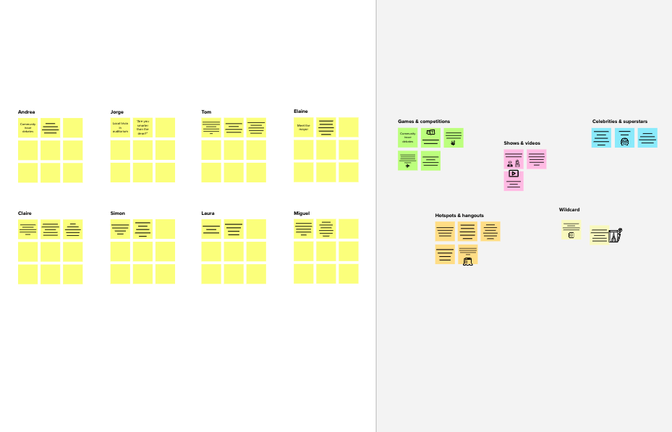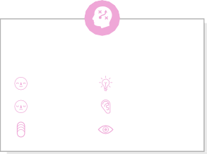

**Template**

**Need some inspiration?**

See a finished version of this template to kickstart your work.

[**Open example**](https://app.mural.co/template/e5a93b7b-49f2-48c9-afd7-a635d860eba6/93f1b98d-b2d2-4695-8e85-7e9c0d2fd9b9)